TASK 2

2&3

\*Response time  for Get,Post,Patch,Put,Delete methods is more than 200ms (Not consistent)

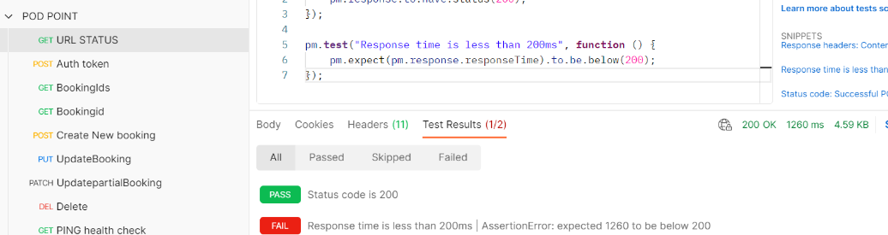

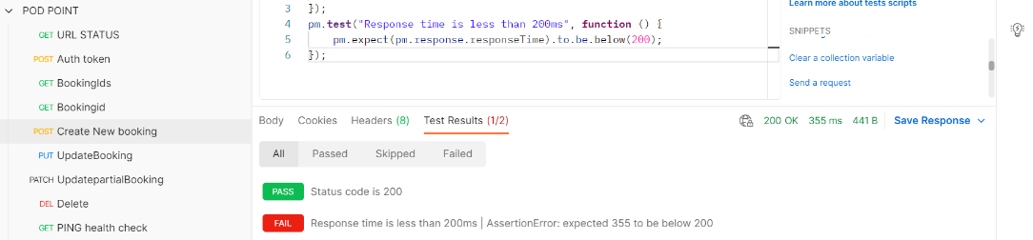

\*\*Post method for token response should be 201 not 200 due to a token  created

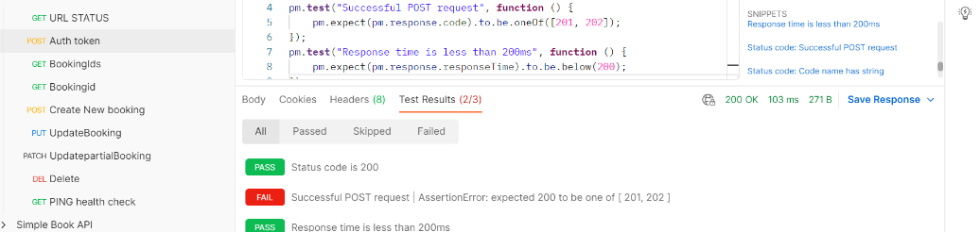

\*\*Input of invalid data  firstname(john12), lastname(doe34) in json body for creation of new booking results in 200 response should not be allowed. It should also be a 201 response code not 200

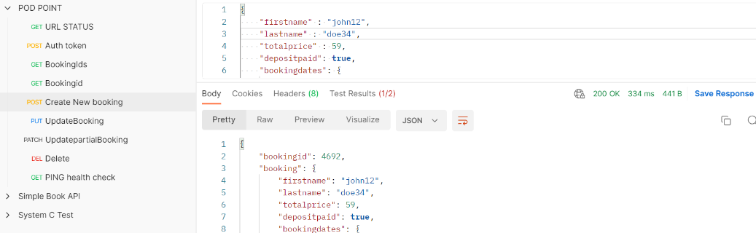

\*Input of a future date in checking and earlier date in checkout is allowed and response of 200 is received

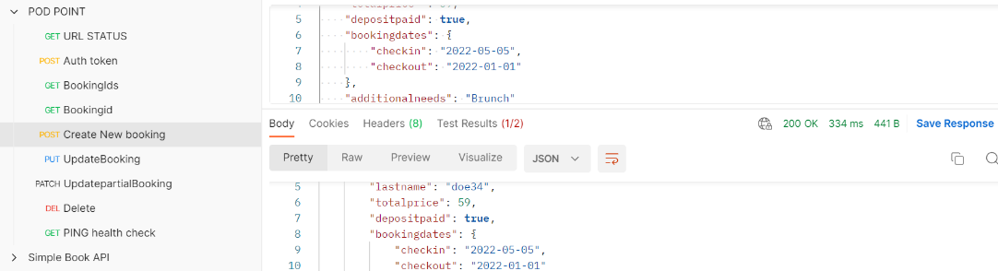

4.

The tests I have written are to check the response codes are as expected, response time should be under 200ms ,body response matches expected